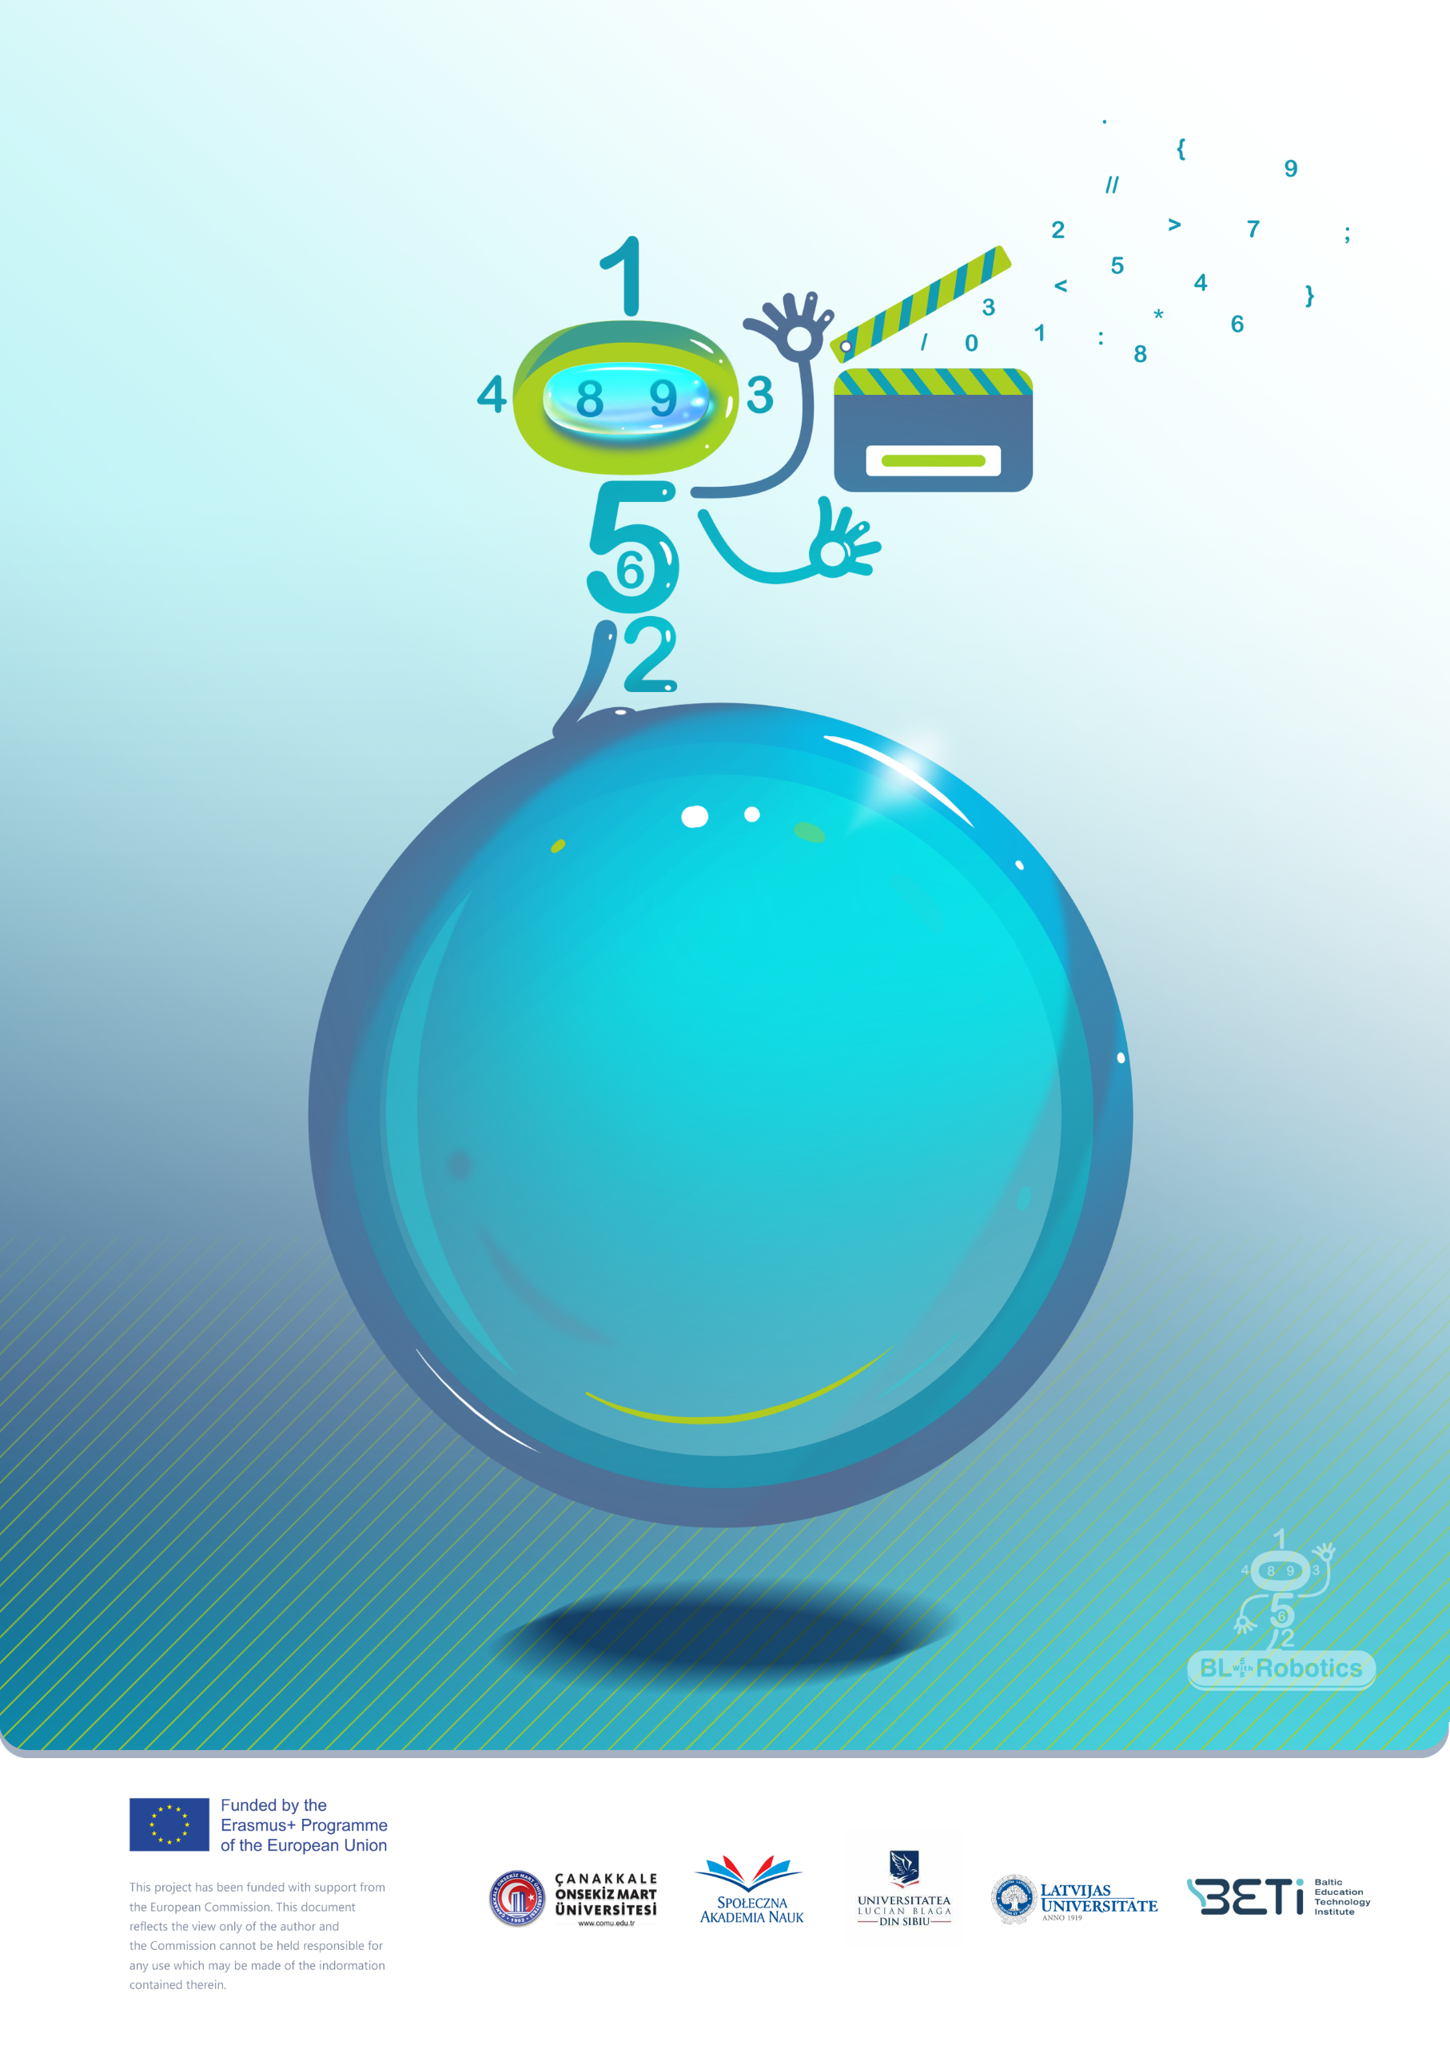

Magic Shape!

UL

Scenario title/name of the game: Magic Shape. Tangram

Children’s age (primary school students):7-8 years old

Time needed:15 minutes

Content/Subject: Geometry (shapes: triangle and quadrilaterals)

Aim of the activity:Describe, classify, and relate two-dimensional shapes

# Introduction

This game aims to develop logical thinking using geometrical shapes as a pretext to play. The story of the game, appropriated for the students age, will take them in a scenario where they can create any objects by using their knowledge!

## Resources:

Programable robot

Shapes: triangle, quadrilaterals

Tangram

# A detailed description of the scenario

Geometric shapes can work their magic. Triangles and quadrilaterals together make miraculous things. Become a magician and make magic out of shapes!

# Steps

1. Decide together what shapes do you need to build a object (square, triangle, rectangle).
2. Explore the object on the digital task map.
3. Arranges the shapes to match the digital map.
4. Compares the object on the digital task map with the constructed object.
5. Get new object on digital task map.

# Tips and tricks for the teacher

Give instructions at the beginning of the game!

Let children make mistakes. Trying again and discovering the error is part of the game!

Use pictures that show how each piece of the shape is placed.

Use images that show only the exterior lines of the object.

Encourage pupils to figure out and create the objects themselves.

# Variants of the scenario/the game

Students can work out task form textbook (see Figure 1, Figure 2)

|  |  |
| --- | --- |
|  |  |
| ***Figure 1. Task*** (Helmane, Dāvida, 2014, 70) | |
|  | Draw the shape on the grid paper!  Cut the shape along the lines!  From the 8 cut-out shapes, create the object from picture!  With a classmate, figure out and create your own picture! Use one or two sets of cut-out shapes! |
| ***Figure 2. Task*** (Helmane, Dāvida, 2014, 47) |  |

***Literature:***

Helmane, I., Dāvida, A., (2014). *Matemātika 1.klasei. Pirmā daļa*, Lielvārds (in Latvian)

Helmane, I., Dāvida, A., (2014). *Matemātika 1.klasei. Otrā daļa*, Lielvārds (in Latvian)