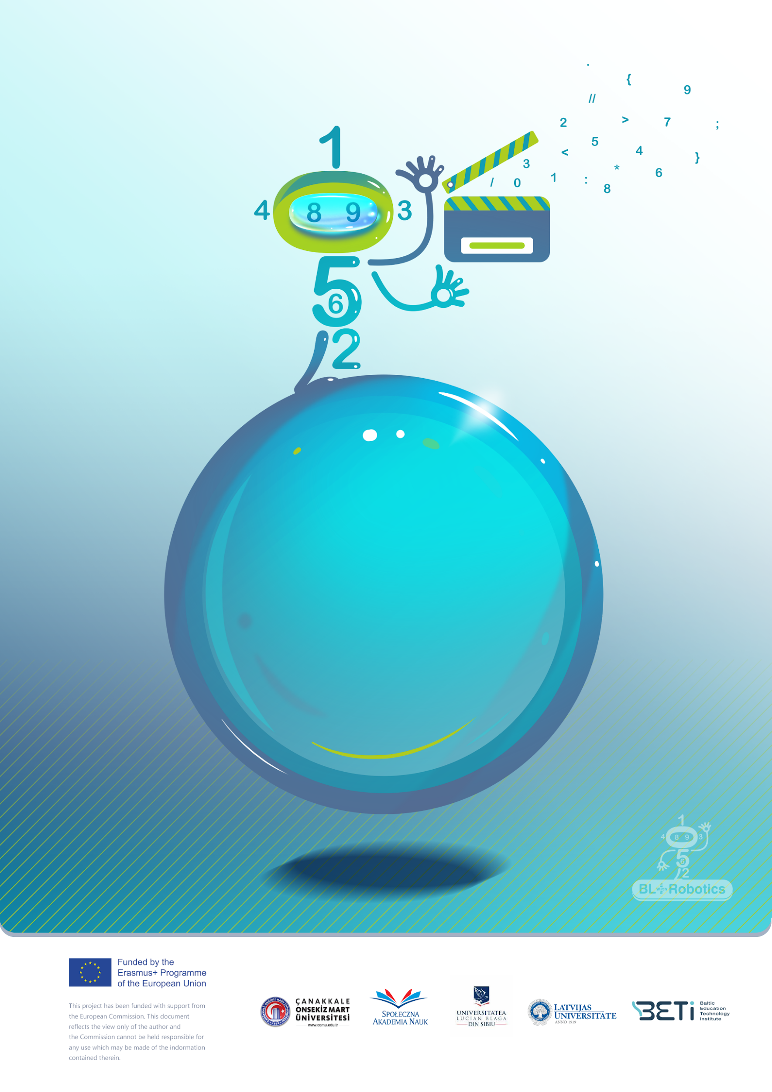

***Scenario title/name of the game:*** Magic Numbers

***Children’s age (primary school students):*** 6-7 years old

***Time needed:*** 15 minutes

***Content/Subject:*** Numbers 1-10

***Aim of the activity:*** Modelling, representing numbers up to 10

# Introduction

This game aims to develop logical thinking using numbers as a pretext to play. The story of the game, appropriated for the students’ age, will take them in a scenario where they can manipulate numbers.

## Resources:

***Programmable robot***

***Numbers game***

***Number cards,*** ***Dot cards***

# A detailed description of the scenario

Numbers can work their magic. Numbers together make miraculous things. Become a magician and make magic out of numbers!

# Steps

1. Decide together what number cars do you need.
2. Decide together what dots cards do you need.
3. Explore the task on the digital task map.
4. Arranges the cards to match the digital map.
5. Compares the task on the digital task map with the solved task.
6. Get new task on digital task map.

# Tips and tricks for the teacher

Give instructions at the beginning of the game!

Let children make mistakes. Trying again and discovering the error is part of the game!

Play the game in teams to add competition, if you aim to increase the speed of solving the tasks!

This game introduces students to the world of numbers, helping them to understand that numbers are not just symbols, but actually indicate a quantity.

The game includes activities related to addition, subtraction and multiplication, thus developing students' skills in these areas.

The game provides an opportunity to understand the sequence of numbers and the relationships between different numbers.

„Numbers" takes time and patience to learn and play successfully. It develops children's perceptual skills and ability to concentrate on the task.

# Variants of the scenario/the game

Students can work out task form textbook (see Figure 1)

|  |  |
| --- | --- |
|  | Find 1! |
|  | Find 2! |
|  | Find 3! |
|  | Find 4! |
|  | Find 5! |
|  |  |
|  |  |
| ***Figure 1 Task*** (Anspoka, Birzgale, Dzērve, Helmane, Leite, 2011) | | |

***Literature*:**

Anspoka, Z., Birzgale, E., Dzērve, I., Helmane, I., Leite, I. (2011). *Sākam mācīties! Otrā grāmata.* Lielvārds (in Latvian).