

***Scenario title/name of the game:*** Let's Find Guliver's Game Island

***Children’s age (primary school students):*** 7 years old

***Time needed:*** 15 minutes

***Content/Subject:*** Numbers, geometry, measurement

***Aim of the activity:*** Problem solving with one-digit numbers.

# Introduction

This activity aims to:

* develop mathematical-logical skills and making operations by answering a problem that includes four operations,
* understand our money by making money and time calculations
* understand the concepts of measuring units by answering the problem involving measuring liquid, measuring length
* comprehend the properties of geometric shapes by answering the problem involving calculating the perimeter and area of geometric shapes.
* develop social-emotional aspects through collaborative work as a team
* develop algorithmic thinking skills by giving commands to robots.

Your activity will lead students to a scenario using their one-digit problem solving skills with age-appropriate game!

## Resources:

1. A game floor like the one below (the picture of the game room will be placed at the end of this game floor)

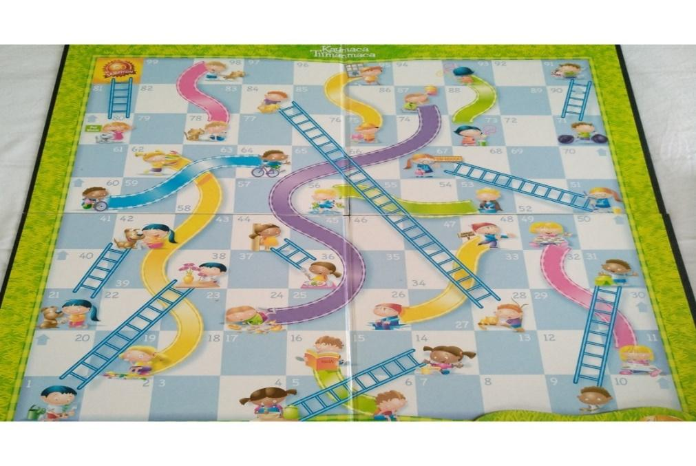

2. Two robots or arrows

3. Dice with 9, 8, 7, 6, 5, 4 on their faces

4. Problem cards

# A detailed description of the scenario

Have you read Gulliver's Travels by Jonathan Swift? (Students' answers are taken) He talks about the travels of a doctor named Lemuel Gulliver. The doctor tells the extraordinary stories that he encounters in the pieces of land he has taken refuge in after surviving his sea accidents, and that he has experienced in different countries, each more beautiful than the other. Of course, the doctor's travels were not easy. He went through very difficult roads to reach some places. Now, shall we help Gulliver in one of these challenging adventures? Say what? Gulliver dreams that there is a wonderful game island. On this island, there is a clear sea, delicious fruits, and fun playgrounds for children. When he wakes up in the morning, he immediately investigates how he can find that island. He asks the people on the ship. A little boy on the ship says he knows about that island. He draws a map and says that he can go there with this map. However, he also states that there are obstacles to be overcome for this and that the questions on the map must be answered. I have that map. Shall we go to the island on this map together?

# Steps

1. 2 different teams of 2-3 people are formed by the teacher, taking into account the number of children who will carry out the activity.

2. The scenario is shared with the students by the teacher.

3. Students share their feelings and thoughts about the scenario.

4. The teacher opens the game floor as a map. And he explains the rules of the game and the way of playing (Rules: One of each group will be given one of the dice marked 9, 8, 7, 6, 5, 4 on their surface. In addition, each team will also choose a problem card. Both groups will put their robots at the starting point. One person from the group will roll the dice, the first problem on the problem card they have chosen is asked to the team by the teacher. When the team answers the problem correctly, they determine the path on the playing floor for the robot to advance as much as the number on the dice, programs its own robot and press start. Then the same procedures are applied to the other team. The game continues until one of the teams reaches the island)

5. Each group chooses one of the problem cards and gives it to the teacher as its own card.

6. Each team rolls the dice when it's their turn, answers the problem, programs their Robot (or put the arrows in the right order) and hits start!

7. The game continues until one of the teams reaches the island.

# Tips and tricks for the teacher

1. Let's pay attention to the heterogeneity of teams to be formed of 2-3 people.

2. Ask each team to name their robot in a collaborative cooperative learning framework.

3. Give the rules and information of the event at the beginning.

4. Have children express their feelings and thoughts about the scenario aloud, and encourage them in this regard.

5. Be careful not to leave the problem card chosen by the teams with them. Because if they have it, they can solve and prepare the questions in advance.

6. While preparing the problem cards, make sure that each problem card is composed of problems that will cover the same subject and achievements as the other and have similar difficulty levels.

7. Prevent children from being afraid of making mistakes in coding robots, do not allow negative criticism of their friends. Encourage them when they make mistakes and make them feel that it is part of the game.

**Scenario implementation and other resources:**

Maps, arrows, other materials especially created for this scenario.

**Variants of the scenario/the game**:

If there is too much competition between the teams in the activity, the activity can also be carried out as a single group, with the children throwing the dice, answering the problem and coding the robot respectively. This activity can be applied in different age groups by changing the problem cards.

**APPENDIX: EXAMPLES OF PROBLEM CARD**

**1. CARD**

1. A greengrocer buys a kilogram of apple for 2 liras and sells it for 5 liras. How much profit does this greengrocer make when he sells 3 kilos of apples?

2. Aysel goes to school 5 days a month and goes to sports on the other days. How many days did Aysel go to the gym in a month?

3. I bought half of milk with my 8 liras, how many liras do I have left?

4. If 9 pencils are divided equally into three boxes, how many pencils will there be in each box?

5. How many liters of water does a family that consumes 2 liters of water per day consume in 4 days?

6. 1 plate is filled with 2 ladles of soup. How many ladles will fill 3 plates?

7. A turtle travels 3 meters in 2 hours. How many centimeters does a turtle travel in 6 hours?

8. How many wires are needed for the perimeter of a triangle with an equal side length of 2 cm and the other side of 3 cm?

**2. CARD**

1. The price of Yankı's dream toy is 9 liras. How much money does Yankı have, who needs 3 liras to buy this toy?

2. Mr. Hasan goes to a doctor's check-up every 4 months. How many times a year does Mr. Hasan go for a check-up?

3. How many halves a watermelon makes 4 quarters of watermelon?

4. A grocery store adds 7 kilograms to 2 kilograms of sugar. If he fills 3 bags of total sugar equally, how many kilograms of sugar will be in each bag?

5. Selma has 2 liras. If her sister's money is 4 times that of Selma, how many liras do the two of them have in total?

6. A pack of milk comes in 2 cups. How many cups is 3 packs of milk?

7. My pencil is 4 sharpeners long. My notebook is 2 pencils long. How long is my notebook to open?

8. How many cm of wire are needed for the perimeter of a rectangle with a short side of 2 cm and a long side of 3 cm?

**3. CARD**

1. Özlem bought 4 of the 2 TL pens and gave 10 TL to the seller. How many lira change will Özlem receive?

2. Since Can's father plays computer games for 2 hours a day on the weekend, how many hours does he play computer games in a week?

3. 2 whole cakes are cut into quarters and distributed to the guests. How many guests?

4. In how many days will Hasan spend 9 liras, who spends 3 liras every day?

5. How much is 6 times the second smallest one-digit natural number less than 9?

6. A pot is watered with 2 glasses of water a week. How many glasses of water is watered in 1 month?

7. When Arda goes from his room to the kitchen, he walks 6 meters. What is the distance between the room and the kitchen?

8. How many cm of wire are needed for the perimeter of a square with a side of 2 cm?